**Spring Framework**

**Java 8 features:**

**Java 8** was released in 18th March 2014, so it’s high time to look into Java 8 Features

1. [forEach() method in Iterable interface](https://www.journaldev.com/2389/java-8-features-with-examples#iterable-forEach)
2. [default and static methods in Interfaces](https://www.journaldev.com/2389/java-8-features-with-examples#interface-default-static-method)
3. [Functional Interfaces and Lambda Expressions](https://www.journaldev.com/2389/java-8-features-with-examples#functional-interface-lambdas)
4. [Java Stream API for Bulk Data Operations on Collections](https://www.journaldev.com/2389/java-8-features-with-examples#java-stream-api)
5. [Java Time API](https://www.journaldev.com/2389/java-8-features-with-examples#java8-time)
6. [Collection API improvements](https://www.journaldev.com/2389/java-8-features-with-examples#java8-collection)
7. [Concurrency API improvements](https://www.journaldev.com/2389/java-8-features-with-examples#java8-concurrency)
8. [Java IO improvements](https://www.journaldev.com/2389/java-8-features-with-examples#java8-io)
9. [Miscellaneous Core API improvements](https://www.journaldev.com/2389/java-8-features-with-examples#java8-core)

**ForEach():**

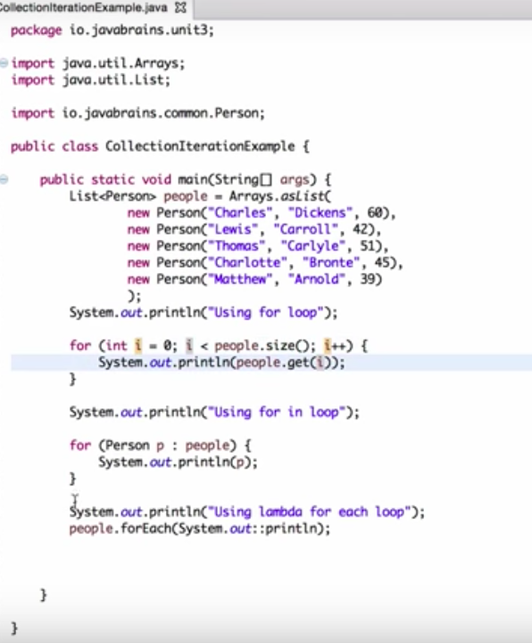

Whenever we need to traverse through a Collection, we need to create an Iterator whose whole purpose is to iterate over and then we have business logic in a loop for each of the elements in the Collection. We might get [ConcurrentModificationException](https://www.journaldev.com/378/java-util-concurrentmodificationexception) if iterator is not used properly.

**Using Consumer Interface:**

The Consumer interface is [a functional interface](http://www.baeldung.com/java-8-functional-interfaces) (an interface with a single abstract method). It accepts an input and returns no result.

Here’s the definition:

|  |  |
| --- | --- |
| 1  2  3  4 | @FunctionalInterface  public interface Consumer {      void accept(T t);  } |

With that in mind, let’s consider the example below:

|  |  |
| --- | --- |
| 1  2  3  4  5  6  7  8  9  10  11  12 | List<String> names = new ArrayList<>();  names.add("Larry");  names.add("Steve");  names.add("James");  names.add("Conan");  names.add("Ellen");    names.forEach(new Consumer<String>() {      public void accept(String name) {          System.out.println(name);      }  }); |

**Lamda expression:**

Here, the lambda expression is an anonymous representation of a function descriptor of a functional interface.

|  |  |
| --- | --- |
| 1 | names.forEach(name -> System.out.println(name)); |

Since the introduction of lambda expressions in Java 8, this is probably the most common way to use the *forEach* method.

**Functional Interface:**

* An interface with exactly one abstract method becomes Functional Interface.
* @FunctionalInterface [annotation](https://www.journaldev.com/721/java-annotations) is used for interface.
* We don’t need to use @FunctionalInterface annotation to mark an interface as Functional Interface. @FunctionalInterface annotation is a facility to avoid accidental addition of abstract methods in the functional interfaces

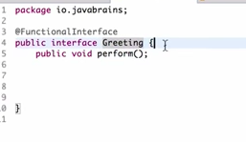

**Java Stream:**

* Stream API will allow sequential as well as parallel execution. This is one of the best feature for me because I work a lot with Collections and usually with Big Data, we need to filter out them based on some conditions.
* ParallelStreams make it very easy to multi thread operations.
* A stream pipeline consist of a source , followed by zero or more intermediate operations and terminal operations.
* Streams can be created from Collections, Lists, Sets, ints, longs, doubles, arrays, lines of file.

Stream operations are either intermediate or terminal.

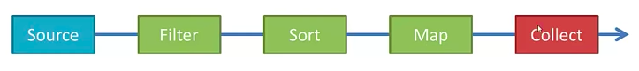

**Intermediate operations:**

Such as **filter, map or sort** return a stream so we can chain multiple Intermediate operations

**Terminal operations:**

Such as **forEach, collect or reduce** are either void or return a non-stream result.

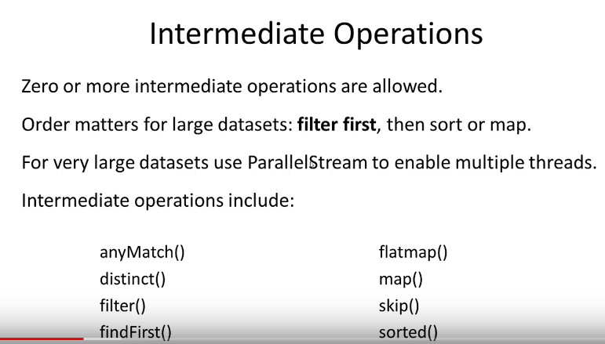

Difference between map and flatmap ?

 The map operation produces one output value for each input value, whereas the flatMap operation produces an arbitrary number (zero or more) values for each input value.

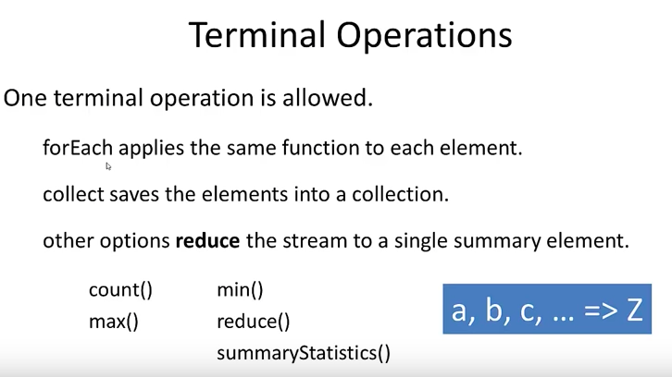

**Filter, forEach operations:**

**Filter:** We can use filter() method to test stream elements for a condition and generate filtered list.

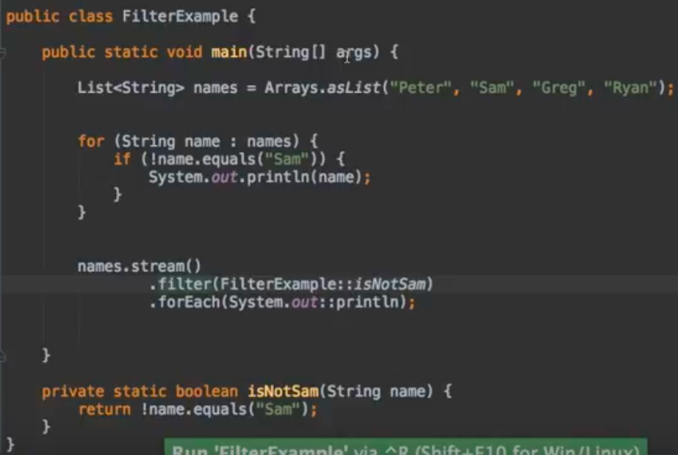

Here instead of for loop , we are using the filter and foreach

**map() :** We can use map() to apply functions to an stream. Let’s see how we can use it to apply upper case function to a list of Strings.

Stream<String> names = Stream.of("aBc", "d", "ef"); System.out.println(names.map(s -> {

return s.toUpperCase();

}).collect(Collectors.toList()));

//prints [ABC, D, EF]

**What is Diamond Operator?**

The point for diamond operator is simply to reduce typing of code when declaring generic types. It doesn't have any effect on runtime whatsoever.

List<String> list = new ArrayList();

**What is ThreadPool Excutor?**

**What is Gererics?**

**Whats is Spring Beans?**

**1) What is Spring Framework?**

It is a lightweight, loosely coupled and integrated framework created to address the complexity of enterprise application development.

Because id its layered architecture, we can be selective about which of its components to use while also providing a cohesive framework for J2EE application development.

**2) Advantages of Spring Framework?**

* Layered architecture.
* Enable POJO Programming
* Dependency Injection and Inversion of Control.
* Open Source and no vendor lock-in

**3) Features of Spring Framework?**

* Light Weight
* Inversion of Control (IOC)
* Aspect Oriented (AOP)
* Container
* MVC Framework
* Transaction Management
* JDBC Exception Handling

**4) How many modules are there in Spring?**

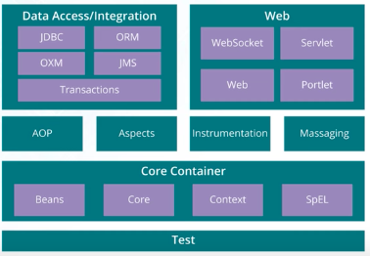

* **Spring Context** – for dependency injection.
* **Spring AOP** – for aspect oriented programming.
* **Spring DAO** – for database operations using DAO pattern
* **Spring JDBC** – for JDBC and DataSource support.
* **Spring ORM** – for ORM tools support such as Hibernate
* **Spring Web Module** – for creating web applications.
* **Spring MVC** – Model-View-Controller implementation for creating web applications, web services etc.

**5) What is Spring Configuration file?**

* Spring configuration file is XML file which
* Contain the classes information
* Describes how classes are configured and introduced each other.

**6) What are the different components of spring application?**

1. An Interface that defines the functions
2. The implementation that contains Properties, its setter and getter methods, functions etc
3. Spring AOP
4. The spring configuration XML File
5. Client Program that uses the functions

**7) Major Version in Spring Framework?**

* **Spring 2.5:** made annotation driven configuration possible.
* **Spring 3.0:** made great use of java 5 improvements in the language.
* **Spring 4.0:** 1 st version to fully support java features.

**8) What are the various ways of using spring?**

1. Full-fledged spring web app
2. Spring middle-tier provides help of a third-party web framework
3. Remote usage scenario
4. EJB-Wrapping existing POJOs.

**9) What is Spring IOC Container?**

* Create the objects
* Wire them together
* Configure them
* Mange their complete lifecycle from creation till destruction
* Uses dependency injection (DI) to manage the components that make up an application.

**Note:** we won’t create the objects here, those constructed by spring framework

**10) What do you mean Dependency Injection (DI)?**

* We don’t create objects but describe how they should be created
* We don’t directly connect components and services together in code but describe which services are needed by which components in a configuration file
* A container (IOC Container) is then responsible for hooking it all up.

**11) How many ways DI can be done?**

1) **Constructor Injection:** Dependencies are provided as construction parameters.

2) **Setter Injection:** Dependencies are assigned through JavaBeans Properties (ex: setter method)

3) **Interface Injection:** Injection is done through an interface.

But only Constructor Injection and Setter Injection are supported in spring.

**12) Difference between Constructor Injection and setter Injection?**

|  |  |
| --- | --- |
| **Constructor Injection** | **Setter Injection** |
| There is no Partial Injection | There can be Partial Injection |
| It doesn’t overrides the setter Property | It overrides the constructor property if both are defined |
| It will create new instance if any modification is done | It will not create new instance If modification is done |
| It is better for too many properties | It is better for few properties |

**13)How many types of IOC containers are there is spring?**

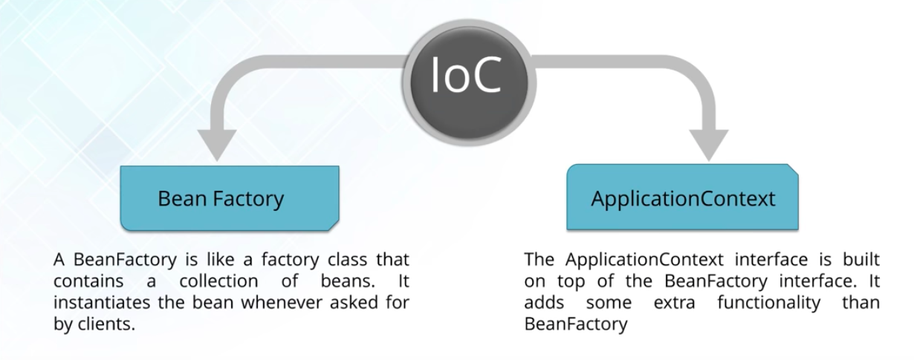

**14) Differentiate between Bean Factory and Application Context?**

|  |  |
| --- | --- |
| **Bean Factory** | **Application Context** |
| Use Lazy Initialization | Use Eager/Aggressive Initialization |
| Explicitly provided a resource object using the syntax | Create and manages resources objects on its own |
| Doesn’t supports internationalization | Supports internationalization |
| Annotation based dependency injection is not supported | Annotation based dependency Injection is supported |

**15) List some of the benefits of IOC?**

* It minimizes the amount of code in application
* Makes application easy to test
* Loose coupling is promoted with minimal efforts and least intrusive mechanism
* IOC containers support eager instantiation and lazy loading of service

**What is a Spring Bean?**

* A normal POJO class managed by Spring IOC container are called Spring beans. It is core part of Spring application.
* . We use Spring ApplicationContext to get the Spring Bean instance.
* Spring IoC container manages the life cycle of Spring Bean, bean scopes and injecting any required dependencies in the bean.

**16) Explain Spring Beans?**

* The objects that form backbone of the users application
* It is an object that is instantiated, assembled and managed by IOC Container
* They are created with the configuration metadata

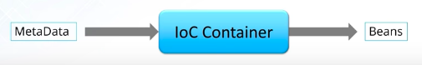

**17) How Configuration metadata is provided to the Spring Container?**

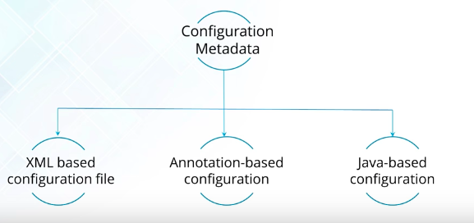

**What are different ways to configure a class as Spring Bean?**

There are three different ways to configure Spring Bean.

1. **XML Configuration**: This is the most popular configuration and we can use bean element in context file to configure a Spring Bean. For example:

<bean name="myBean" class="com.journaldev.spring.beans.MyBean"></bean>

1. **Java Based Configuration**: If you are using only annotations, you can configure a Spring bean using @Bean annotation. This annotation is used with @Configuration classes to configure a spring bean. Sample configuration is:

@Configuration

@ComponentScan(value="com.journaldev.spring.main")

public class MyConfiguration {

@Bean

public MyService getService()

{

return new MyService();

}

}

To get this bean from spring context, we need to use following code snippet:

AnnotationConfigApplicationContext ctx = new AnnotationConfigApplicationContext(

MyConfiguration.class);

MyService service = ctx.getBean(MyService.class);

1. **Annotation Based Configuration**: We can also use @Component, @Service, @Repository and @Controller annotations with classes to configure them to be as spring bean. For these, we would need to provide base package location to scan for these classes. For example:

<context:component-scan base-package="com.journaldev.spring" />

#### 8. What is Spring XML based configuration?

In Spring XML based configuration, you define all dependency in an XML file. You define all your beans with tag in XML file and all dependencies are read using this XML file.

Forexample :Sample ApplicationContext.xml file

|  |
| --- |
| <!--?xml version="1.0" encoding="UTF-8"?-->  <?xml version="1.0" encoding="UTF-8"?>  <beans xmlns="http://www.springframework.org/schema/beans"  xmlns:xsi="http://www.w3.org/2001/XMLSchema-instance" xmlns:aop="http://www.springframework.org/schema/aop"  xsi:schemaLocation="http://www.springframework.org/schema/beans http://www.springframework.org/schema/beans/spring-beans-3.0.xsd">    <bean id="CountryBean" class="org.arpit.javapostsforlearning.Country">  <property name="countryName" value="India"/>  <property name="capital" ref="CapitalBean"/>  </bean>  <bean id="CapitalBean" class="org.arpit.javapostsforlearning.Capital">  <property name="capitalName" value="Delhi"/>  </bean>  </beans> |

You can read this ApplicationContext.xml using:

|  |  |
| --- | --- |
|  | ApplicationContext appContext = new ClassPathXmlApplicationContext("ApplicationContext.xml"); |

**What is spring java based configuration?**

In Spring Java based configuration, you inject all dependencies using java class only. You can use @Configuaration and @Bean annotations to do it.

|  |
| --- |
| package org.arpit.java2blog.config;  import org.arpit.java2blog.model.Country;  import org.springframework.context.annotation.Bean;  import org.springframework.context.annotation.Configuration;    @Configuration  public class ApplicationConfiguration {    @Bean(name="countryObj")  public Country getCountry()  {  return new Country("India");  }    } |

Above file is equivalent to below spring configuration xml

|  |
| --- |
| <?xml version="1.0" encoding="UTF-8"?>  <beans xmlns="http://www.springframework.org/schema/beans"  xmlns:xsi="http://www.w3.org/2001/XMLSchema-instance"  xmlns:context="http://www.springframework.org/schema/context"  xsi:schemaLocation="http://www.springframework.org/schema/beans  http://www.springframework.org/schema/beans/spring-beans-3.0.xsd  http://www.springframework.org/schema/context  http://www.springframework.org/schema/context/spring-context-3.0.xsd">  <context:annotation-config/>  <bean id="countryObj" class="org.arpit.java2blog.Country" >  <property name="countryName" value="India"/>  </bean>  </beans> |

To get above bean to application context, you need to use below code

|  |
| --- |
| ApplicationContext appContext = new AnnotationConfigApplicationContext(ApplicationConfiguration.class);  Country countryObj = (Country) appContext.getBean("countryObj"); |

**18) How Many bean scopes are supported by the spring?**

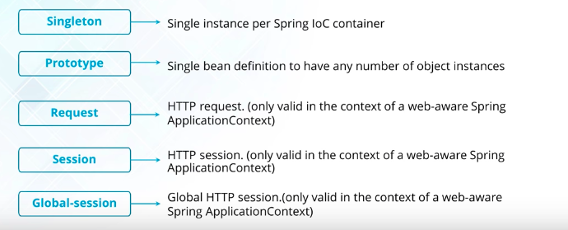

1. [**singleton**](https://www.journaldev.com/1377/java-singleton-design-pattern-best-practices-examples): Only one instance of the bean will be created for each container. This is the default scope for the spring beans. While using this scope, make sure spring bean doesn’t have shared instance variables otherwise it might lead to data inconsistency issues because it’s not thread-safe.
2. **prototype**: A new instance will be created every time the bean is requested.
3. **request**: This is same as prototype scope, however it’s meant to be used for web applications. A new instance of the bean will be created for each HTTP request.
4. **session**: A new bean will be created for each HTTP session by the container.
5. **global-session**: This is used to create global session beans for Portlet applications.

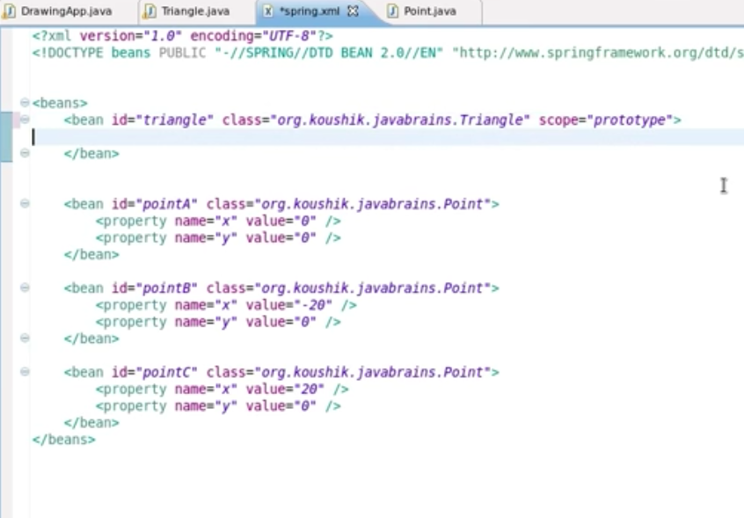

#### . What is default scope of bean in Spring?

singleton is default scope of a bean in Spring. You have to explicitly change scope of a bean if you want different scope

#### What do you mean by bean autowiring in Spring?

In Spring framework, you can wire beans automatically with auto-wiring feature. To enable it, just define the “**autowire**” attribute in .The Spring container can **autowire** relationships between collaborating beans without using and elements which helps cut down on the amount of XML configuration

|  |
| --- |
| <bean id="countryBean" class="org.arpit.java2blog.Country" autowire="byName"> |

#### What are different modes of autowiring supported by Spring?

There are following autowiring modes which can be used to instruct Spring container to use autowiring for dependency injection.

**no:**

Default, no auto wiring, set it manually via “ref” attribute as we have done in dependency injection via settor method post.

**byName:**

Autowiring by property name. Spring container looks at the properties of the beans on which *autowire* attribute is set to *byName* in the XML configuration file and it tries to match it with name of bean in xml configuration file.

**byType:**

Autowiring by property datatype. Spring container looks at the properties of the beans on which *autowire* attribute is set to *byType* in the XML configuration file. It then tries to match and wire a property if its **type** matches with exactly one of the beans name in configuration file. If more than one such beans exists, a fatal exception is thrown.

**contructor:**

byType mode in constructor argument.

**autodetect:**

Spring first tries to wire using autowire by *constructor*, if it does not work, Spring tries to autowire by *byType*.

**What is Spring Bean Life Cycle?**

**19) What is the Bean life cycle in spring Bean Factory Container?**

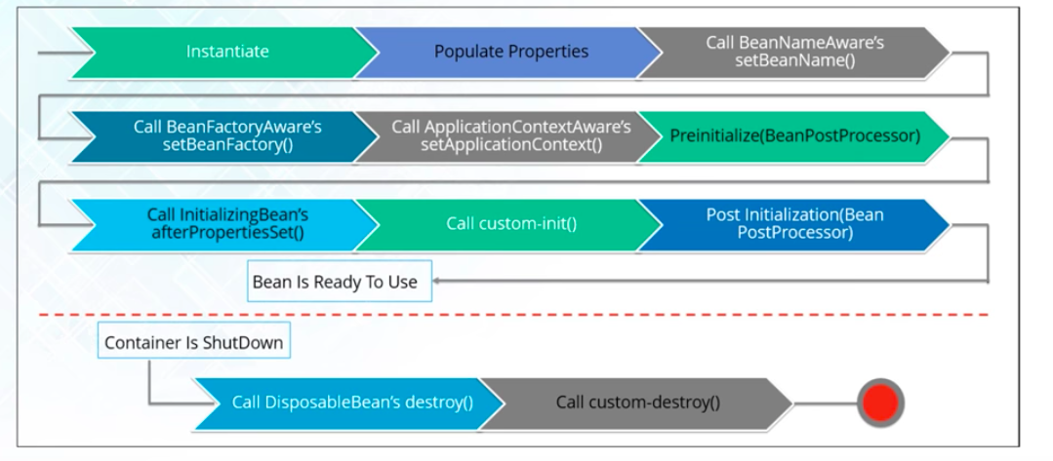

**20) Explain Inner beans in spring?**

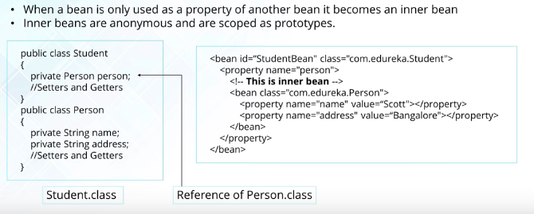

**21) What is Bean Wiring?**

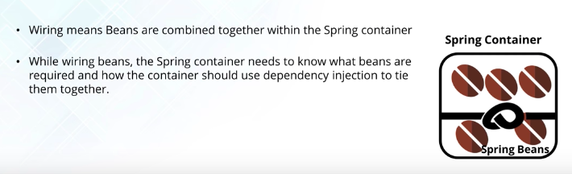

**22) What do you understand the by auto wiring and names the different modes of it?**

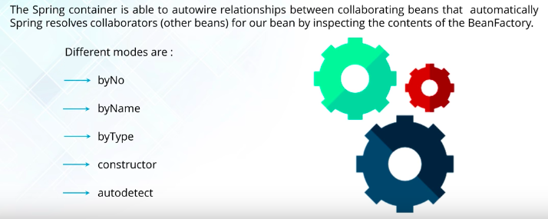

**23) What are the Limitations with auto wiring?**

Overriding possibility is there

Primitive data types are complicated

Confusing nature

**Spring Annotation:**

**24) What do you mean by Annotation –based container configuration?**

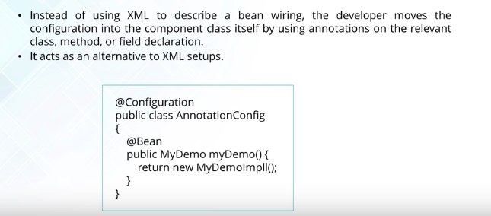

25)

**26) What is the difference between @Component, @Controller, @Repository, and @Service annotation in spring?**

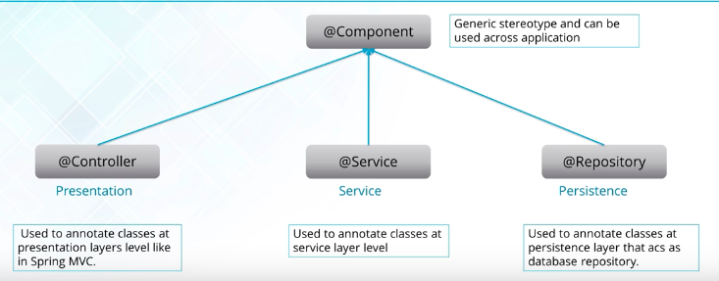

**26) What do you understand by @Required annotation?**

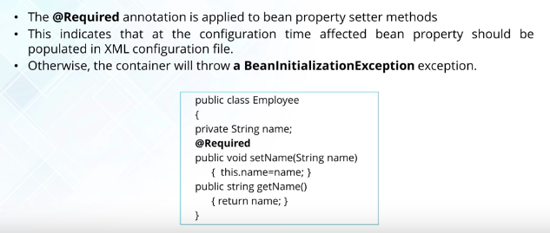

**27) What do you understand @Autowired Annotation?**

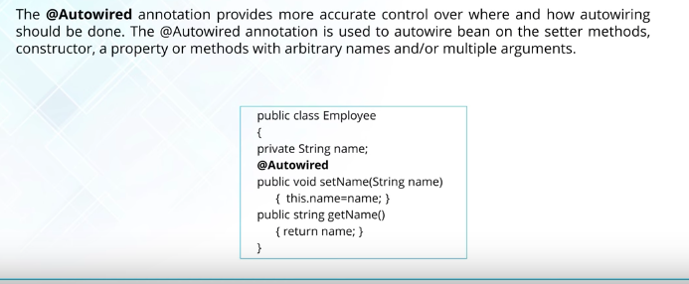

**29) What do you understand by @Qualifier annotation?**

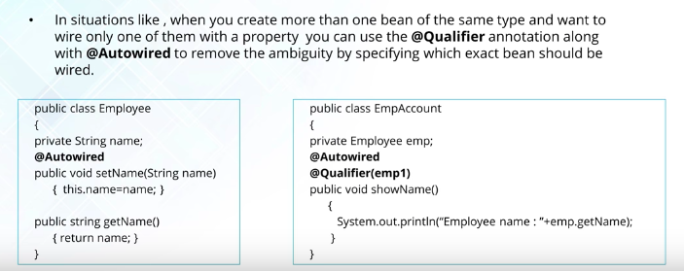

**30) What do you understand by @RequestMapping annotation?**

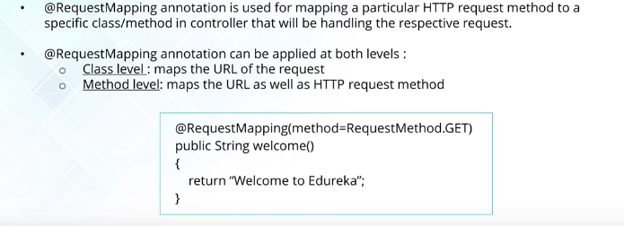

**Spring Data Access:**

**31) Describe Spring DAO support?**

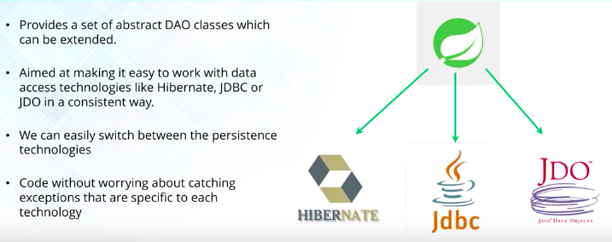

**32) Name the exceptions thrown by the Spring DAO Classes?**

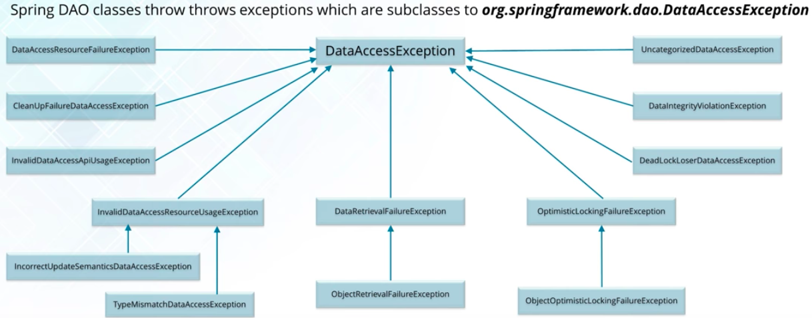

**33) What are the classes presented in the JDBC API?**

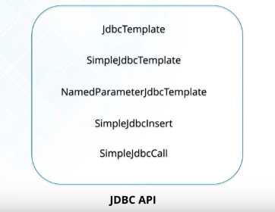

**34) In which way Hibernate can be accessed by using spring?**

There are 2 ways:

1. Inversion of control (IOC) with a Hibernate Template and Callback.
2. Extending HibernateDAOSupport and Applying an AOP Interceptor node

**35) Name the types of transaction management that Spring Supports?**

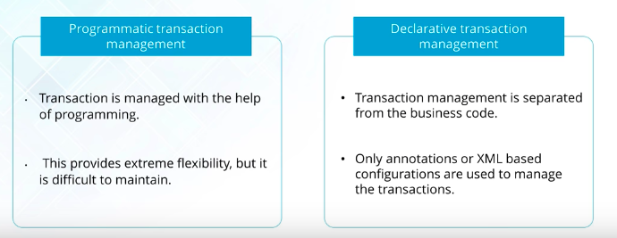

**36) What are the ORM’ S supported by Spring?**

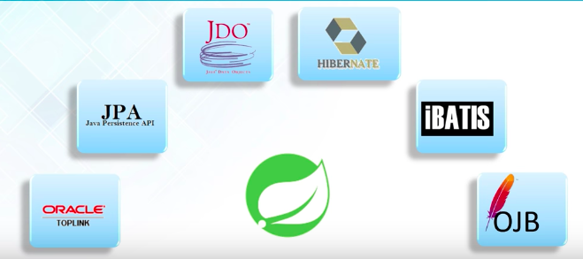

**Spring AOP:**

**37) Describe AOP?**

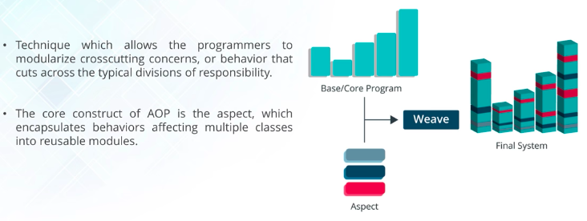

**38) What do you mean by Aspects?**

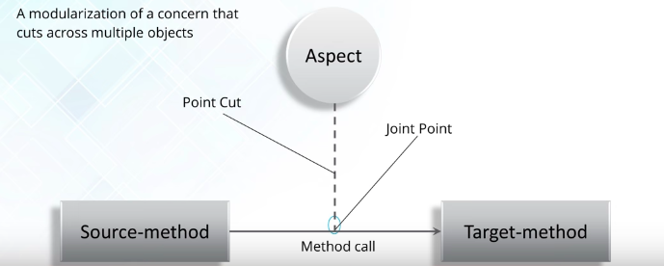

**39) Explain JointPoints?**

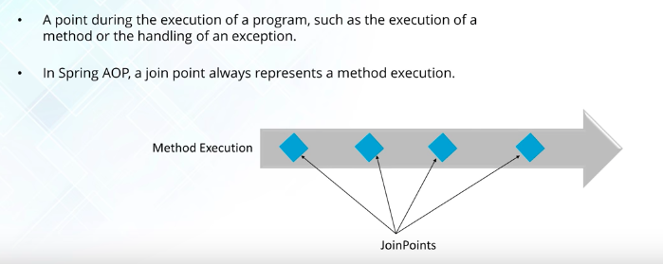

**40) What is Advice?**

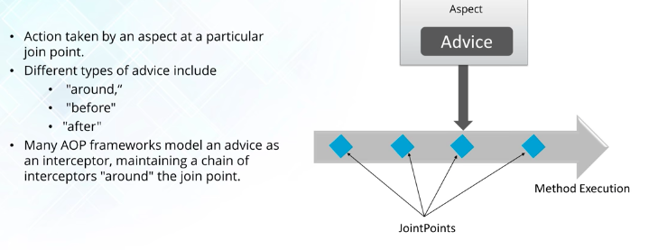

**41) What are the different types of Advices?**

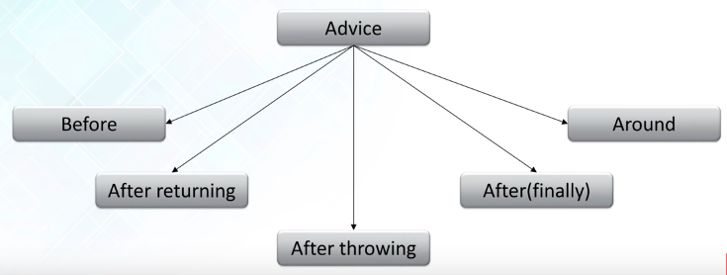

**42) Point Out the difference between concern and cross –cutting concern in Spring AOP?**

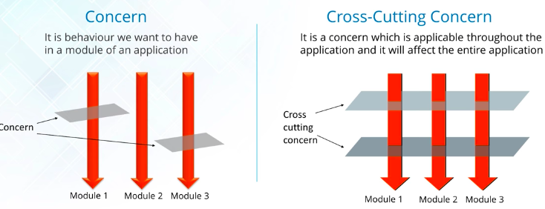

**43) What are the different AOP Implementations?**

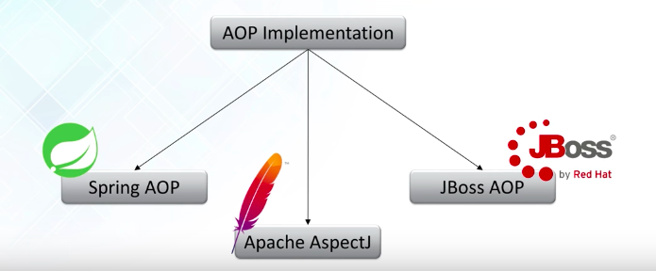

**44) What are the difference between Spring AOP and AspectJ AOP?**

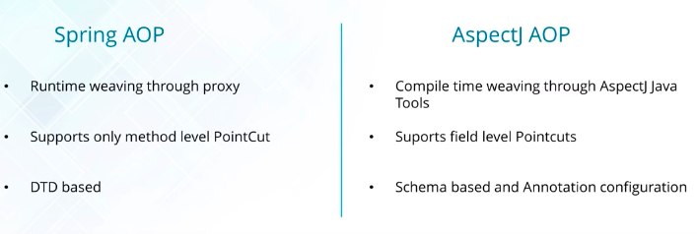

**45) What do you mean by Proxy?**

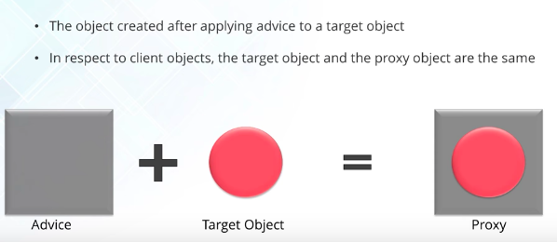

**46) In Spring what is Weaving?**

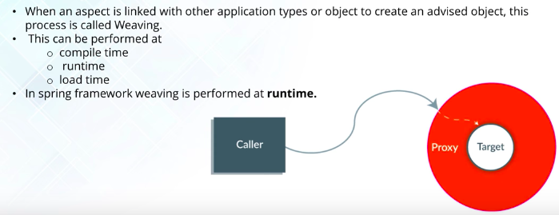

**Spring MVC:**

**47) What do you mean by Spring MVC Framework?**

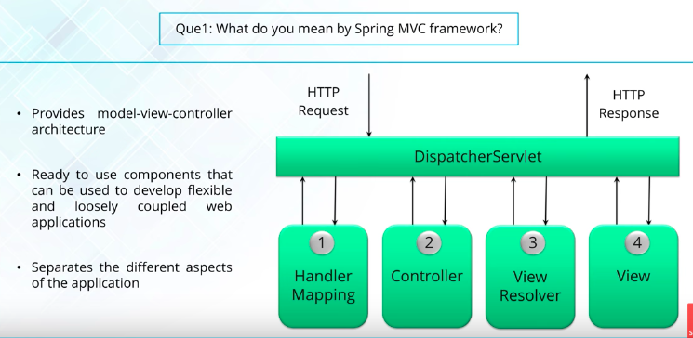

Dispatcher servlet works as front controller, it handles all Http request and Reponses.

**48) Explain WebApplicaitonContext ?**

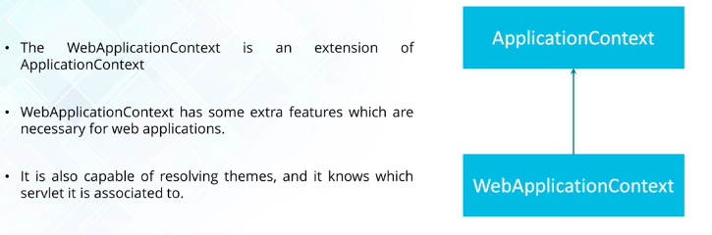

**49) What is Controller in Spring MVC?**

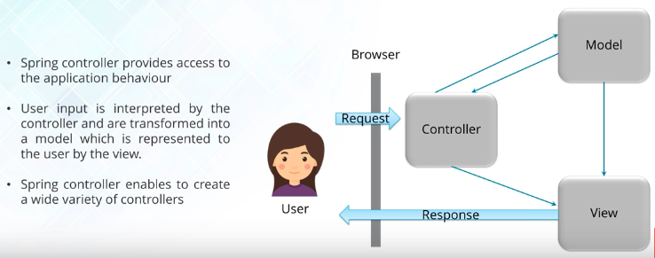

**50) Is Singleton beans are thread-safe in Spring Framework?**

No, singlet beans are not thread safe in spring framework.

**51) can you inject null and empty String values in Spring?**

**Yes, You can.**

**Spring Boot:**

**1) What is Spring Boot?**

Spring + Bootstrap.

Spring Boot makes it easy to create stand-alone, production-grade spring based Applications that you can "just run"

Spring Boot is not a framework, it is a way to ease to create stand-alone application with minimal or zero configurations.

It provides a set of Starter POM’s or gradle build files, which one can use to add required dependencies and also facilitate auto configuration.

Spring Boot automatically configures required classes depending on the libraries on its class path. Suppose your application want to interact with DB, if there are Spring Data libraries on class path then it automatically sets up connection to DB along with the Data Source class.

**2) Features of Spring Boot?**

* Create stand-alone Spring applications
* Embed Tomcat, Jetty or Undertow directly (no need to deploy WAR files)
* Provide opinionated 'starter' POMs to simplify your Maven configuration
* Automatically configure Spring whenever possible
* Provide production-ready features such as metrics, health checks and externalized configuration
* Absolutely no code generation and no requirement for XML configuration

**3) What the difference between spring, Spring MVC and Spring Boot?**

**Spring Framework:**

* Most important feature of Spring Framework is Dependency Injection. At the core of all Spring Modules is Dependency Injection or IOC Inversion of Control
* When DI or IOC is used properly, we can develop loosely coupled applications. And loosely coupled applications can be easily unit tested.

**Spring MVC:**

* Spring MVC Framework provides decoupled way of developing web applications. With simple concepts like Dispatcher Servlet, ModelAndView and View Resolver, it makes it easy to develop web applications.
* The problem with Spring and Spring MVC is the amount of configuration that is needed

**Spring Boot:**

**4) Why we need Spring Boot?**

**5) What are the ways to create the Spring boot application?**

1. Spring Maven Project--https://www.javatpoint.com/spring-maven-project
2. Spring Starter Project Wizard--https://www.javatpoint.com/spring-starter-project-wizard
3. Spring Initializr--https://www.javatpoint.com/spring-initializr
4. Spring Boot CLI--https://www.javatpoint.com/spring-boot-cli

**6) How can you implement Spring Security with Spring Boot?**

Add Spring Security to the class path. Spring Boot will automatically secure all http endpoints if Spring Security is found on the class path.﻿

In order to add security to our Spring Boot application, we need to add the security starter dependency:

|  |
| --- |
| <dependency>  <groupId>org.springframework.boot</groupId>  <artifactId>spring-boot-starter-security</artifactId>  </dependency> |

<http://www.baeldung.com/spring-boot-security-autoconfiguration>

**7) Testing for Spring Boot?**

<http://www.baeldung.com/spring-boot-testing>

<https://docs.spring.io/spring-boot/docs/current/reference/html/boot-features-testing.html>

**8)What Version of Spring Boot did you use In your Project?**

Spring boot-1.2.0(Dec 2014)

Spring Boot-1.3.0(Nov 2015)

Spring Boot 1.5(May-2017)

Spring Current Version-2.0 (March 2018)

**9) What are the Spring Boot Dependencies you have used in your Project?**

Spring-boot-Starter Web

Spring-data-mongoDB.

**10) Why Do we Use Spring Boot With Micro Services?**

**11) What are the advantages of Spring Boot?**

**12) How to Create Spring Boot Application Using Maven?**

Add the Spring Boot dependency into Maven.

**13) How can you run the Spring Boot Application on Custom Port?**

By default spring runs on port 8080, but it can be changed by specifying an application-profile.properties file. These are commonly used for different profiles such DEV, PROD, etc. Within the properties file, we can set the port in YAML format or Java Property format.

**14) How can you Configure Logging In Spring Boot Application?**

Logging level can be easily modified in the application-profile file. No need to mess with configs for log4j2!

**How to create the Spring MVC Project?**

1. Click on File--->New ---> Dynamic Web Project, then it show following dialog:

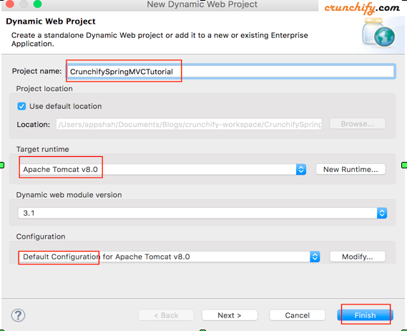

Enter Project name, Target runtime, Configuration, and then click on Finish.

Add dependency Library’s to Build Path.

1. **Convert to Maven:**

Right Click on Project then **configure**->**Convert to Maven Project**, then it create the POM.xml

Open POM.xml, add few Dependencies Like **spring-core**, **spring-context**, **spring-webmvc**

1. **Web.xml, dispatcher-config.xml:**

Create the xml file under **WebContent/WEB-INF** with name **web.xml**

Create the xml file under **WebContent/WEB-INF** with name **dispatcher-config.xml**

**What is Spring LDAP?**

Spring LDAP is a Java library for simplifying LDAP operations, based on the pattern of Spring's JdbcTemplate. The framework relieves the user of common chores, such as looking up and closing contexts, looping through results, encoding/decoding values and filters, and more.

|  |
| --- |
| <dependencies>  <dependency>  <groupId>org.springframework.ldap</groupId>  <artifactId>spring-ldap-core</artifactId>  <version>2.3.1.RELEASE</version>  </dependency>  </dependencies> |

<https://javabeat.net/introduction-to-spring-ldap/>

<http://www.baeldung.com/spring-data-ldap>

**JPA**

**What is Spring JPA?**

JPA-Java Persistence API

Add dependency in pom.xml

<dependency>

<groupId>org.springframework.boot</groupId>

<artifactId>spring-boot-starter-data-jpa</artifactId>

</dependency>

**refer the other Spring doc for example**

**What is PostgreSQL?**

This is regarded as one of the most successful open source database in the world. This is also used to create advanced applications. This relies on Object relational database management system. Familiarity with UNIX and Linux can be an added advantage while using PostgreSQL.

These are the following features ,which are present in PostgreSQL they are

1) Object relational database

2) Extensibility and support for SQL

3) Database validation and flexible API

4) Procedural languages and MVCC

5) Client server and WAL.

**What is Actuator?**

* In essence, Actuator brings production ready features to our application.
* Actuator is mainly used to expose operational information about running application-health, metrics, info, dump, env etc, it uses HTPP endpoints or JMX beans to enables us to interact with it.
* Monitoring our app, gathering metrics, understanding traffics or the state of our database become trivial with this dependency.

Dependency: spring-boot-starter-actuator.

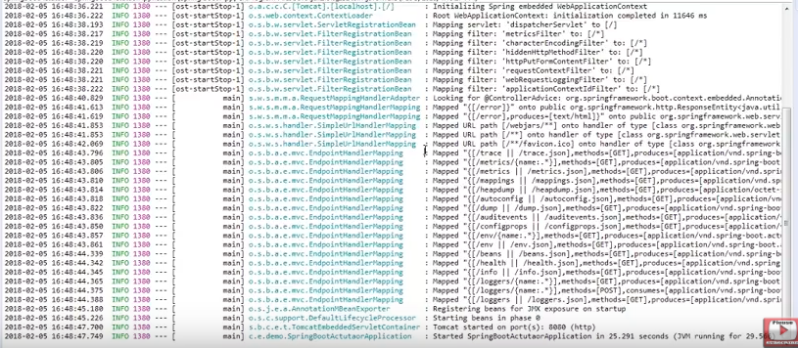

Here are some of the most common Spring Boot Actuator endpoints:

1. **/health**: It shows application health information.
2. **/info**: It displays arbitrary application info.
3. **/metrics**: It gives all metrics related information for the current application.
4. **/trace**: It displays trace information for last few HTTP requests.
5. /env:
6. /loggers:
7. beans

**How to print the logs in file?**

Just go to application.properties:

logging.level.root=INFO

loging.file=application.log

then it print the INFO logs in project path/application.logs file

**Shedule in Spring boot?**

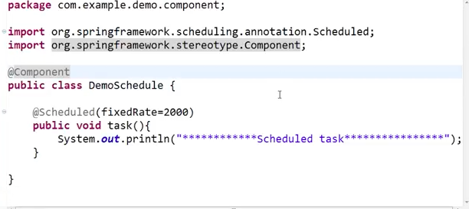

it will run for every 2000 sec , as per above code

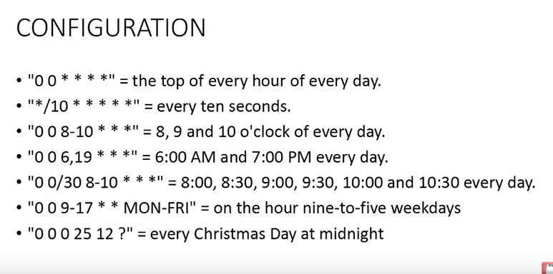

**Error Management in Spring Boot:**

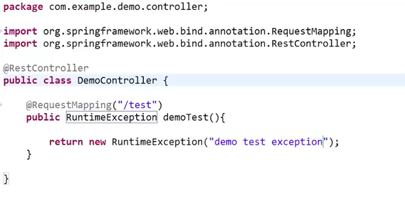

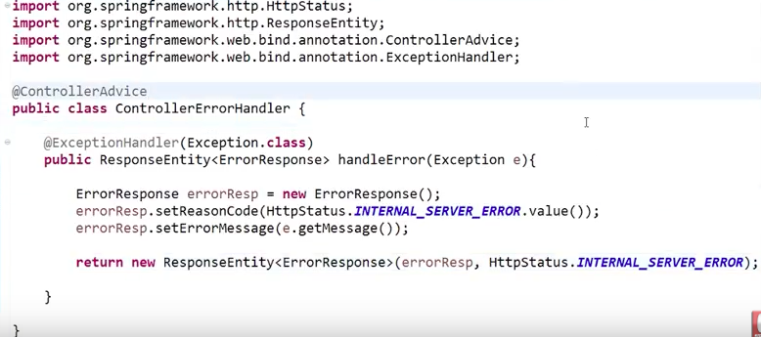

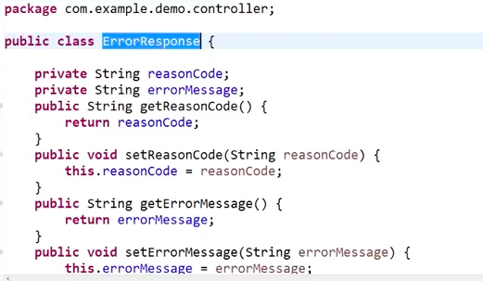

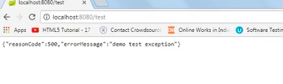

**Spring Boot –junit Test:**

Create the Spring boot application:

i) Create the RestController with name as DemoController

|  |
| --- |
| package hello;  import org.springframework.stereotype.Controller;  import org.springframework.web.bind.annotation.RequestMapping;  import org.springframework.web.bind.annotation.ResponseBody;  @Controller  public class DemoController {  @RequestMapping("/test")  public String test() {  return "Hello";  }  } |

ii) Now right click on Controller then click on junit , then it create the test class

|  |
| --- |
| @RunWith(SpringRunner.class)  @SpringBootTest  @AutoConfigureMockMvc  public class DemoControllerTest {  @Autowired  private MockMvc mockMvc;  @Test  public void shouldReturnDefaultMessage() throws Exception {  this.mockMvc.perform(get("/test")).andDo(print()).andExpect(status().isOk())  .andExpect(content().string(containsString("Hello")));  }  } |

iii) Then right click on test class click run as test.

Then it show success or failure of test cases

Here instead of @SpringBootTest, we can use @WebMvcTest

**Caching Data with Spring**

1)

Add the

dependencies { compile("org.springframework.boot:spring-boot-starter-cache") }

2)Add the annotation to Spring boot application

@EnableCaching

* The [@EnableCaching](https://docs.spring.io/spring/docs/current/javadoc-api/org/springframework/cache/annotation/EnableCaching.html) annotation triggers a post processor that inspects every Spring bean for the presence of caching annotations on public methods. If such an annotation is found, a proxy is automatically created to intercept the method call and handle the caching behavior accordingly.
* The annotations that are managed by this post processor are [Cacheable](https://docs.spring.io/spring/docs/current/javadoc-api/org/springframework/cache/annotation/Cacheable.html), [CachePut](https://docs.spring.io/spring/docs/current/javadoc-api/org/springframework/cache/annotation/CachePut.html) and [CacheEvict](https://docs.spring.io/spring/docs/current/javadoc-api/org/springframework/cache/annotation/CacheEvict.html)

3)

add the cachable annotation for any bean object creation

|  |
| --- |
| package hello;  import org.springframework.cache.annotation.Cacheable;  import org.springframework.stereotype.Component;  @Component  public class SimpleBookRepository implements BookRepository {  @Override  @Cacheable("books")  public Book getByIsbn(String isbn) {  simulateSlowService();  return new Book(isbn, "Some book");  }  // Don't do this at home  private void simulateSlowService() {  try {  long time = 3000L;  Thread.sleep(time);  } catch (InterruptedException e) {  throw new IllegalStateException(e);  }  }  } |

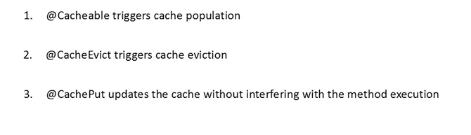

**HATEOAS**

HATEOAS = **H**ypermedia **A**s **T**he **E**ngine **O**f **A**pplication **S**tate.

This is done by including links in a returned response and using only these links to further communicate with the server.

Dependancy:

<dependency>

<groupId>org.springframework.boot</groupId>

<artifactId>spring-boot-starter-hateoas</artifactId>

</dependency>

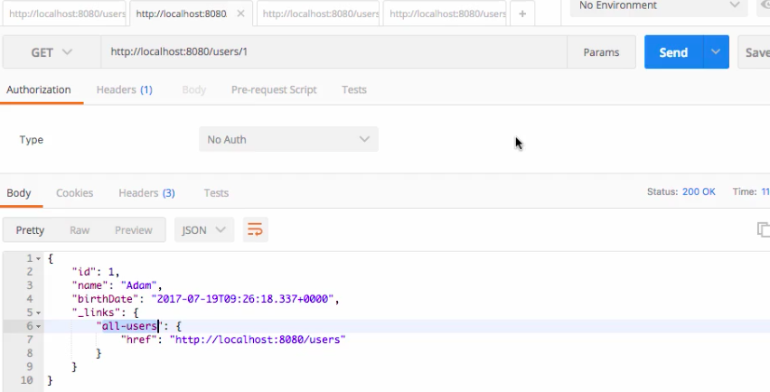

here if we see, we added “_links” json object , that’s added by the Hateoas depenancy, but we need to write following logic as well

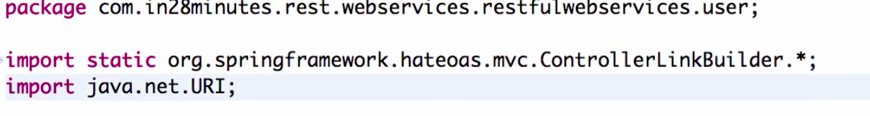

here we need add the static import of ControllerLinkBuilder.

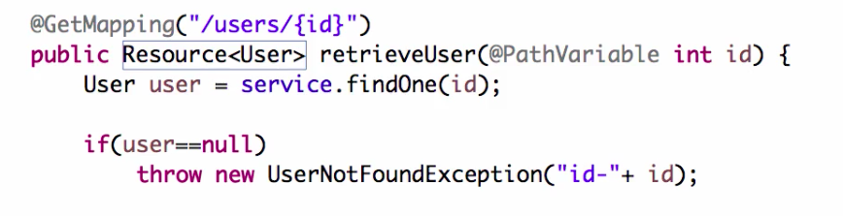

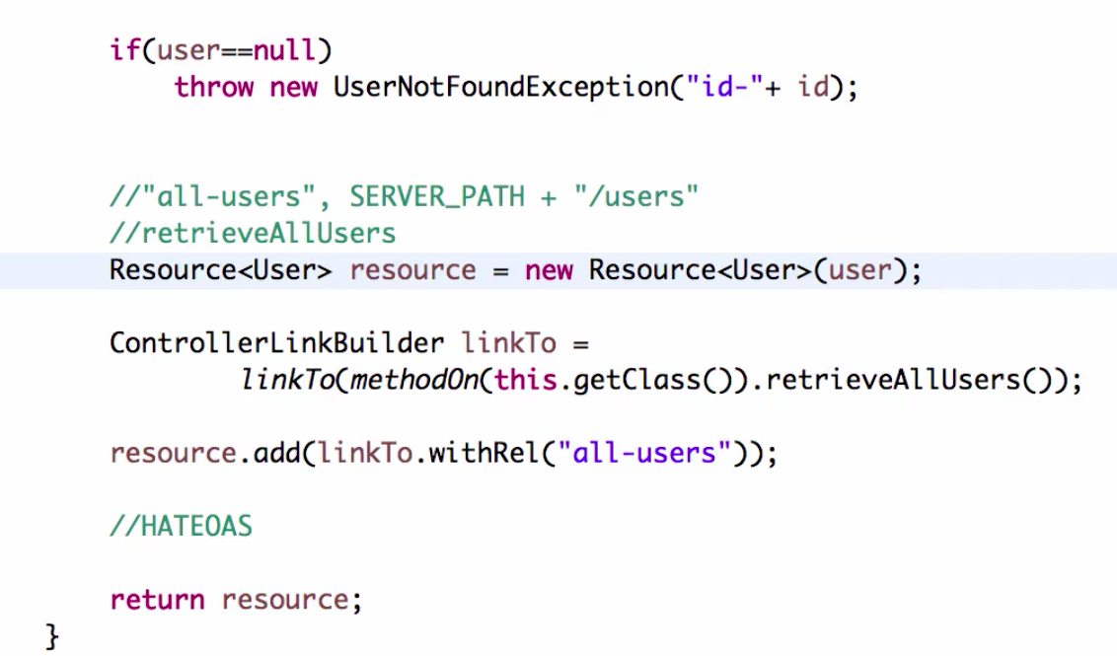

Here we used linkTo method achieve this functionality

Her we adding the retriveAllUser() method for the linkTO using methodOn

WithRel to name the jsonObject “all-users”

Here return type should be Resource<User>

**Internationalization:**

**Basic Authentication using Spring Security:**

Add the dependency in pom.xml:-

|  |
| --- |
| <dependency>  <groupId>org.springframework.boot</groupId>  <artifactId>spring-boot-starter-security</artifactId>  </dependency> |

By adding this, automatically configure the Basic authentication to spring boot application,

Once restart the server

Then we can see the security password in logs



Every time our you run the application , it creates new Password

if we didn’t add this password in Authorization then it throws un authorization error

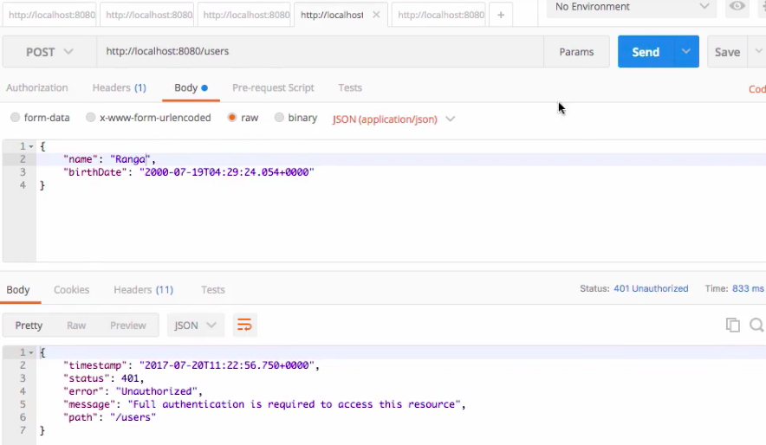

Now we need to add as BasicAuth,

Here

Type: Basic Auth

Username: user

Password : security password in logs

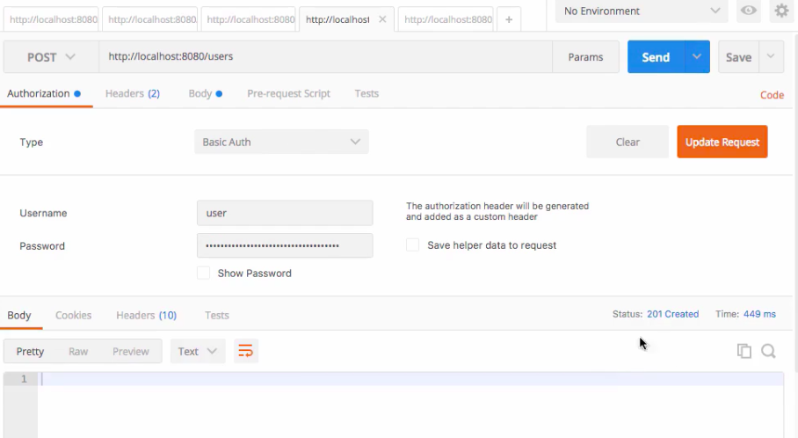

**Or**

We can do another way like; add the following details in application.properties

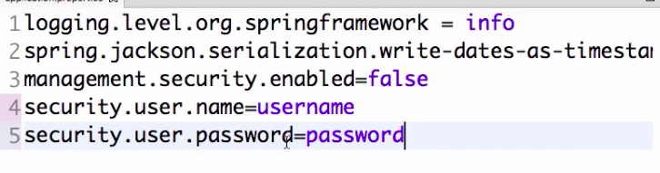

the now change the details in Authorization

username: username

password: password

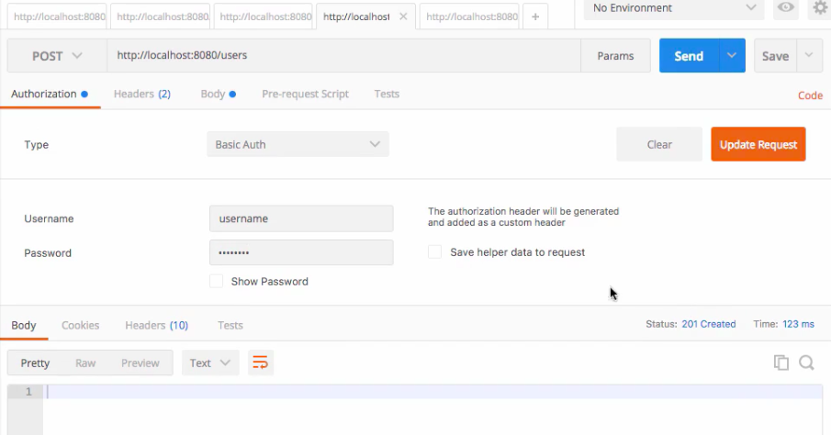

**Swagger:**

We need to add 2 dependency’s

1) Springfox -Swagger

|  |
| --- |
| <dependency>  <groupId>io.springfox</groupId>  <artifactId>springfox-swagger2</artifactId>  <version>2.8.0</version>  <scope>compile</scope>  </dependency> |

2) Swagger UI

|  |
| --- |
| **<dependency>**  **<groupId>io.springfox</groupId>**  **<artifactId>springfox-swagger-ui</artifactId>**  **<version>2.8.0</version>**  **<scope>compile</scope>**  **</dependency>** |

**Create the class**

@Configuration

@EnableSwagger2

public class SpringSwaggerConfig {

@Bean

public Docket **apiDocket**() {

return new Docket(DocumentationType.SWAGGER_2)

.**select**()

.**apis**(RequestHandlerSelectors.**any**())

.**paths**(PathSelectors.**any**())

.**build**();

}

}

Of course, you can provide many more configuration settings as we'll see later, but this is a minimalistic configuration, which does the following:

* *@EnableSwagger2* enables SpringFox support for Swagger 2.
* *DocumentationType.SWAGGER_2* tells the Docket bean that we are using version 2 of Swagger specification.
* *select()* creates a builder, which is used to define which controllers and which of their methods should be included in the generated documentation.
* *apis()* defines the classes (controller and model classes) to be included. Here we are including all of them, but you can limit them by a base package, class annotations and more.
* *paths()* allow you to define which controller's methods should be included based on their path mappings. We are now including all of them but you can limit it using regex and more.

**For API-doc:**

http://localhost:8080/v2/api-docs

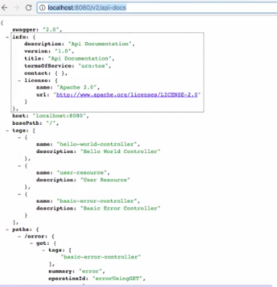

**For Swagger UI**

http://localhost:8080/swagger-ui.html

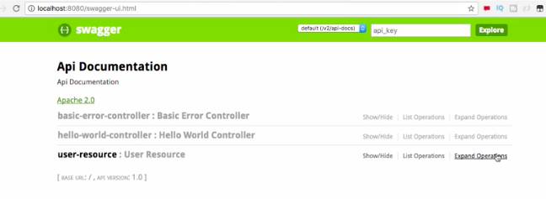

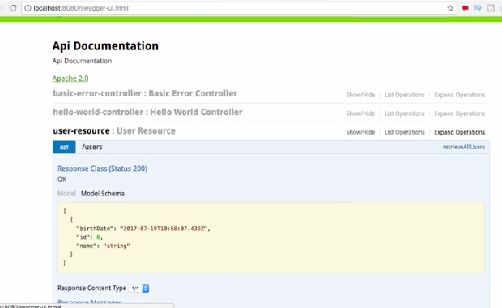

**Best Practices:**

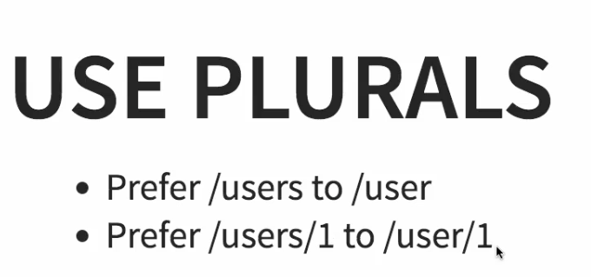

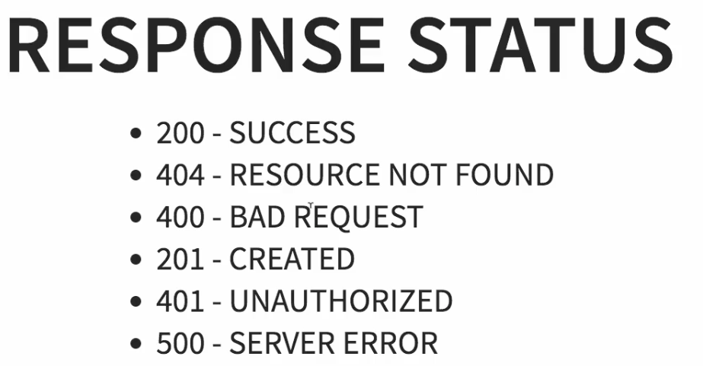

# Spring Boot + Spring Data JPA + Oracle example:

<https://www.mkyong.com/spring-boot/spring-boot-spring-data-jpa-oracle-example/>

https://github.com/springframeworkguru/spring-boot-oracle-example

Tools used in this article :

1. Spring Boot 1.5.1.RELEASE
2. Spring Data 1.13.0.RELEASE
3. Hibernate 5
4. Oracle database 11g express
5. Oracle JDBC driver ojdbc7.jar
6. HikariCP 2.6
7. Maven
8. Java 8

1) we need to add following dependency’s: jpa, oracle driver,HikariCP

<!-- Spring data JPA, default tomcat pool, exclude it -->

<dependency>

<groupId>org.springframework.boot</groupId>

<artifactId>spring-boot-starter-data-jpa</artifactId>

<exclusions>

<exclusion>

<groupId>org.apache.tomcat</groupId>

<artifactId>tomcat-jdbc</artifactId>

</exclusion>

</exclusions>

</dependency>

<!-- Oracle JDBC driver -->

<dependency>

<groupId>com.oracle</groupId>

<artifactId>ojdbc7</artifactId>

<version>12.1.0</version>

</dependency>

<!-- HikariCP connection pool -->

<dependency>

<groupId>com.zaxxer</groupId>

<artifactId>HikariCP</artifactId>

<version>2.6.0</version>

</dependency>

**2)application.Properties**

|  |
| --- |
| spring.main.banner-mode=off  # create and drop tables and sequences, loads import.sql  spring.jpa.hibernate.ddl-auto=create-drop  # Oracle settings  spring.datasource.url=jdbc:oracle:thin:@localhost:1521:xe  spring.datasource.username=system  spring.datasource.password=password  spring.datasource.driver-class-oracle.jdbc.driver.OracleDriver  # HikariCP settings  # spring.datasource.hikari.*  spring.datasource.hikari.connection-timeout=60000  spring.datasource.hikari.maximum-pool-size=5  # logging  logging.pattern.console=%d{yyyy-MM-dd HH:mm:ss} %-5level %logger{36} - %msg%n  logging.level.org.hibernate.SQL=debug  #logging.level.org.hibernate.type.descriptor.sql=trace  logging.level.=error |

3) If import.sql is found in the classpath, Hibernate will load it automatically.

import.sql

INSERT INTO "CUSTOMER" (ID, NAME, EMAIL, CREATED_DATE) VALUES(1, 'mkyong','111@yahoo.com', TO_DATE('2017-02-11', 'yyyy-mm-dd'));

INSERT INTO "CUSTOMER" (ID, NAME, EMAIL, CREATED_DATE) VALUES(2, 'yflow','222@yahoo.com', TO_DATE('2017-02-12', 'yyyy-mm-dd'));

INSERT INTO "CUSTOMER" (ID, NAME, EMAIL, CREATED_DATE) VALUES(3, 'zilap','333@yahoo.com', TO_DATE('2017-02-13', 'yyyy-mm-dd'));

4)We need to create the CRUD Repository Interface

package com.mkyong.dao;

import com.mkyong.model.Customer;

import org.springframework.data.jpa.repository.Query;

import org.springframework.data.repository.CrudRepository;

import org.springframework.data.repository.query.Param;

import java.util.Date;

import java.util.List;

import java.util.stream.Stream;

public interface CustomerRepository extends CrudRepository<Customer, Long> {

}

By using this repository we can use finaAlll, fineOne, save,delete in the implementation class

**What's the difference between Oracle and MySQL?**

**Oracle**is the leading database management system released by Oracle Corporation. **MySQL**is a database management system sponsored by a company named MySQL AB. Now, MySQL is also acquired by Oracle Corporation. Compare the major differences between Oracle and MySQL points wise.

**MySQL :**

1. MySQL is an open source and MySQL is available for free download and installation.

2. User authentication is performed in MySQL by using only location, username and password.

3. Flexibility of creating stored procedures and functions using PL/SQL is very less in MySQL.

4. MySQL offers very few commands related to generating output as report and defining variables. MySQL includes only very simple SQL commands.

5. MySQL does not have the audit vault feature in the server.

6. MySQL does not offer tools at enterprise level.

7. MySQL has only table locking facility.

8. MySQL does not have extensive storage features like tablespace, synonym, packages and many others.

9. MySQL database does not support XML.

10.MySQL supports only two character types namely CHAR and VARCHAR.

11.MySQL, temporary tables are visible only within the current active session. When the session expires, the temporary tables are removed automatically.

12.MySQL has only two backup mechanisms namely mysqlhotcopy and mysqldump.

**Oracle :**

1.Only Oracle Express Edition is free of cost. But Oracle Express Edition has very limited features when compared to MySQL. For extensive features, either Oracle Standard Edition or Oracle Enterprise Edition has to be purchased.

2.Oracle provides enhanced database security. User authentication is performed in Oracle by specifying global roles in addition to location, username and password. In Oracle, User authentication is performed by different authentication methods including database authentication, external authentication and proxy authentication.

3.Oracle provides more flexible features for creating stored procedures and functions using PL/SQL.

4.Oracle includes extensive SQL commands in SQL*Plus including commands for generating output as report and defining variables.

5.Oracle provides audit vault facility.

6.Oracle offers tools at enterprise level.

7.Oracle provides the row locking facility as well.

8.Oracle has a very extensive storage features. Oracle supports tablespace, synonym, packages and all other features.

9.Oracle supports and uses XML.

10.Oracle supports four different character data types namely: CHAR, VARCHAR2, NCHAR, NVARCHAR2.

11. In Oracle, temporary tables are persistent across sessions. The temporary table has to be explicitly removed by the User.

12.Oracle offers many backup mechanisms including hot backup, backup, import, export and many others